**Graphic design assignment**

**Good design**



**Reasons why it’s good**

1. Saves time when replacing cables and during maintenance and also during trouble shooting when the link is down.

2. Well the cabling is well managed, there is signal interference resulting in enhanced speed and system performance.

3. Saves money by extending the life existence of your cables and protecting from damage.

**Bad design**

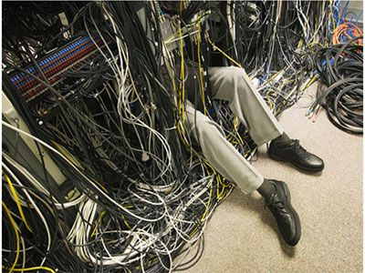

**Reason why it’s bad**